Gergely Daróczi
Looong report
Fri Apr 15 04:36:50 2016
Table of Contents

I have written the below report in 10 mins :)

Dataset
Here I will do a pretty fast report on mtcars which is:
Table continues below
 | mpg | cyl | disp | hp | drat | wt | qsec | vs | am
Mazda RX4 | 21 | 6 | 160 | 110 | 3.9 | 2.62 | 16.46 | 0 | 1
Mazda RX4 Wag | 21 | 6 | 160 | 110 | 3.9 | 2.875 | 17.02 | 0 | 1
Datsun 710 | 22.8 | 4 | 108 | 93 | 3.85 | 2.32 | 18.61 | 1 | 1
Hornet 4 Drive | 21.4 | 6 | 258 | 110 | 3.08 | 3.215 | 19.44 | 1 | 0
Hornet Sportabout | 18.7 | 8 | 360 | 175 | 3.15 | 3.44 | 17.02 | 0 | 0
Valiant | 18.1 | 6 | 225 | 105 | 2.76 | 3.46 | 20.22 | 1 | 0
Duster 360 | 14.3 | 8 | 360 | 245 | 3.21 | 3.57 | 15.84 | 0 | 0
Merc 240D | 24.4 | 4 | 146.7 | 62 | 3.69 | 3.19 | 20 | 1 | 0
Merc 230 | 22.8 | 4 | 140.8 | 95 | 3.92 | 3.15 | 22.9 | 1 | 0
Merc 280 | 19.2 | 6 | 167.6 | 123 | 3.92 | 3.44 | 18.3 | 1 | 0
Merc 280C | 17.8 | 6 | 167.6 | 123 | 3.92 | 3.44 | 18.9 | 1 | 0
Merc 450SE | 16.4 | 8 | 275.8 | 180 | 3.07 | 4.07 | 17.4 | 0 | 0
Merc 450SL | 17.3 | 8 | 275.8 | 180 | 3.07 | 3.73 | 17.6 | 0 | 0
Merc 450SLC | 15.2 | 8 | 275.8 | 180 | 3.07 | 3.78 | 18 | 0 | 0
Cadillac Fleetwood | 10.4 | 8 | 472 | 205 | 2.93 | 5.25 | 17.98 | 0 | 0
Lincoln Continental | 10.4 | 8 | 460 | 215 | 3 | 5.424 | 17.82 | 0 | 0
Chrysler Imperial | 14.7 | 8 | 440 | 230 | 3.23 | 5.345 | 17.42 | 0 | 0
Fiat 128 | 32.4 | 4 | 78.7 | 66 | 4.08 | 2.2 | 19.47 | 1 | 1
Honda Civic | 30.4 | 4 | 75.7 | 52 | 4.93 | 1.615 | 18.52 | 1 | 1
Toyota Corolla | 33.9 | 4 | 71.1 | 65 | 4.22 | 1.835 | 19.9 | 1 | 1
Toyota Corona | 21.5 | 4 | 120.1 | 97 | 3.7 | 2.465 | 20.01 | 1 | 0
Dodge Challenger | 15.5 | 8 | 318 | 150 | 2.76 | 3.52 | 16.87 | 0 | 0
AMC Javelin | 15.2 | 8 | 304 | 150 | 3.15 | 3.435 | 17.3 | 0 | 0
Camaro Z28 | 13.3 | 8 | 350 | 245 | 3.73 | 3.84 | 15.41 | 0 | 0
Pontiac Firebird | 19.2 | 8 | 400 | 175 | 3.08 | 3.845 | 17.05 | 0 | 0
Fiat X1-9 | 27.3 | 4 | 79 | 66 | 4.08 | 1.935 | 18.9 | 1 | 1
Porsche 914-2 | 26 | 4 | 120.3 | 91 | 4.43 | 2.14 | 16.7 | 0 | 1
Lotus Europa | 30.4 | 4 | 95.1 | 113 | 3.77 | 1.513 | 16.9 | 1 | 1
Ford Pantera L | 15.8 | 8 | 351 | 264 | 4.22 | 3.17 | 14.5 | 0 | 1
Ferrari Dino | 19.7 | 6 | 145 | 175 | 3.62 | 2.77 | 15.5 | 0 | 1
Maserati Bora | 15 | 8 | 301 | 335 | 3.54 | 3.57 | 14.6 | 0 | 1
Volvo 142E | 21.4 | 4 | 121 | 109 | 4.11 | 2.78 | 18.6 | 1 | 1
 | gear | carb
Mazda RX4 | 4 | 4
Mazda RX4 Wag | 4 | 4
Datsun 710 | 4 | 1
Hornet 4 Drive | 3 | 1
Hornet Sportabout | 3 | 2
Valiant | 3 | 1
Duster 360 | 3 | 4
Merc 240D | 4 | 2
Merc 230 | 4 | 2
Merc 280 | 4 | 4
Merc 280C | 4 | 4
Merc 450SE | 3 | 3
Merc 450SL | 3 | 3
Merc 450SLC | 3 | 3
Cadillac Fleetwood | 3 | 4
Lincoln Continental | 3 | 4
Chrysler Imperial | 3 | 4
Fiat 128 | 4 | 1
Honda Civic | 4 | 2
Toyota Corolla | 4 | 1
Toyota Corona | 3 | 1
Dodge Challenger | 3 | 2
AMC Javelin | 3 | 2
Camaro Z28 | 3 | 4
Pontiac Firebird | 3 | 2
Fiat X1-9 | 4 | 1
Porsche 914-2 | 5 | 2
Lotus Europa | 5 | 2
Ford Pantera L | 5 | 4
Ferrari Dino | 5 | 6
Maserati Bora | 5 | 8
Volvo 142E | 4 | 2

Descriptives
 | Average | Median | Standard.deviation | Variance
mpg | 20.09 | 19.2 | 6.027 | 36.32
cyl | 6.188 | 6 | 1.786 | 3.19
disp | 230.7 | 196.3 | 123.9 | 15361
hp | 146.7 | 123 | 68.56 | 4701
drat | 3.597 | 3.695 | 0.5347 | 0.2859
wt | 3.217 | 3.325 | 0.9785 | 0.9574
qsec | 17.85 | 17.71 | 1.787 | 3.193
vs | 0.4375 | 0 | 0.504 | 0.254
am | 0.4062 | 0 | 0.499 | 0.249
gear | 3.688 | 4 | 0.7378 | 0.5444
carb | 2.812 | 2 | 1.615 | 2.609

In details

mpg
We found the folloing values here:
21, 21, 22.8, 21.4, 18.7, 18.1, 14.3, 24.4, 22.8, 19.2, 17.8, 16.4, 17.3, 15.2, 10.4, 10.4, 14.7, 32.4, 30.4, 33.9, 21.5, 15.5, 15.2, 13.3, 19.2, 27.3, 26, 30.4, 15.8, 19.7, 15 and 21.4
The mean of mpg is 20.09 while the standard deviation is: 6.027. The most frequent value in mpg is 10.4, but let us check out the frequency table too:
Table continues below
10.4 | 13.3 | 14.3 | 14.7 | 15 | 15.2 | 15.5 | 15.8 | 16.4 | 17.3 | 17.8
2 | 1 | 1 | 1 | 1 | 2 | 1 | 1 | 1 | 1 | 1
Table continues below
18.1 | 18.7 | 19.2 | 19.7 | 21 | 21.4 | 21.5 | 22.8 | 24.4 | 26 | 27.3 | 30.4
1 | 1 | 2 | 1 | 2 | 2 | 1 | 2 | 1 | 1 | 1 | 2
32.4 | 33.9
1 | 1
Tables are boring, let us show the same with a histogram:
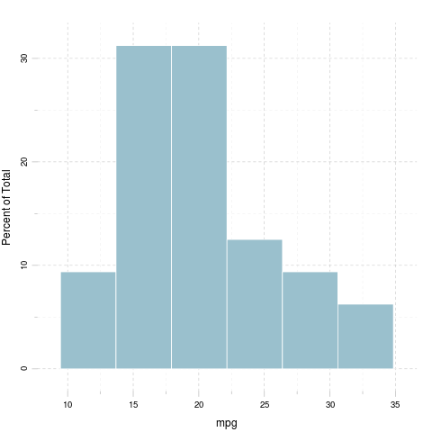

cyl
We found the folloing values here:
6, 6, 4, 6, 8, 6, 8, 4, 4, 6, 6, 8, 8, 8, 8, 8, 8, 4, 4, 4, 4, 8, 8, 8, 8, 4, 4, 4, 8, 6, 8 and 4
The mean of cyl is 6.188 while the standard deviation is: 1.786. The most frequent value in cyl is 8, but let us check out the frequency table too:
4 | 6 | 8
11 | 7 | 14
Tables are boring, let us show the same with a histogram:
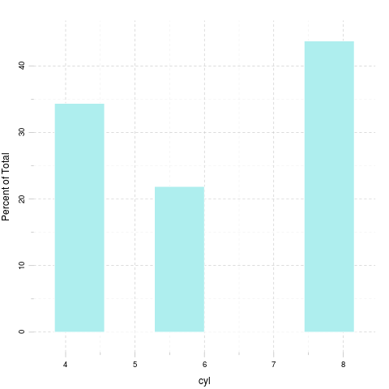

disp
We found the folloing values here:
160, 160, 108, 258, 360, 225, 360, 146.7, 140.8, 167.6, 167.6, 275.8, 275.8, 275.8, 472, 460, 440, 78.7, 75.7, 71.1, 120.1, 318, 304, 350, 400, 79, 120.3, 95.1, 351, 145, 301 and 121
The mean of disp is 230.7 while the standard deviation is: 123.9. The most frequent value in disp is 275.8, but let us check out the frequency table too:
Table continues below
71.1 | 75.7 | 78.7 | 79 | 95.1 | 108 | 120.1 | 120.3 | 121 | 140.8 | 145
1 | 1 | 1 | 1 | 1 | 1 | 1 | 1 | 1 | 1 | 1
Table continues below
146.7 | 160 | 167.6 | 225 | 258 | 275.8 | 301 | 304 | 318 | 350 | 351 | 360
1 | 2 | 2 | 1 | 1 | 3 | 1 | 1 | 1 | 1 | 1 | 2
400 | 440 | 460 | 472
1 | 1 | 1 | 1
Tables are boring, let us show the same with a histogram:
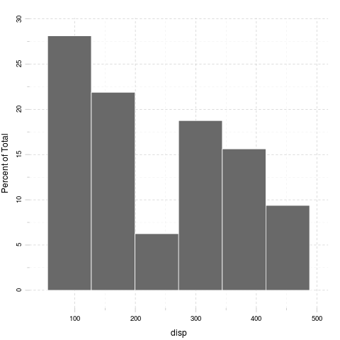

hp
We found the folloing values here:
110, 110, 93, 110, 175, 105, 245, 62, 95, 123, 123, 180, 180, 180, 205, 215, 230, 66, 52, 65, 97, 150, 150, 245, 175, 66, 91, 113, 264, 175, 335 and 109
The mean of hp is 146.7 while the standard deviation is: 68.56. The most frequent value in hp is 110, but let us check out the frequency table too:
Table continues below
52 | 62 | 65 | 66 | 91 | 93 | 95 | 97 | 105 | 109 | 110 | 113 | 123 | 150
1 | 1 | 1 | 2 | 1 | 1 | 1 | 1 | 1 | 1 | 3 | 1 | 2 | 2
175 | 180 | 205 | 215 | 230 | 245 | 264 | 335
3 | 3 | 1 | 1 | 1 | 2 | 1 | 1
Tables are boring, let us show the same with a histogram:
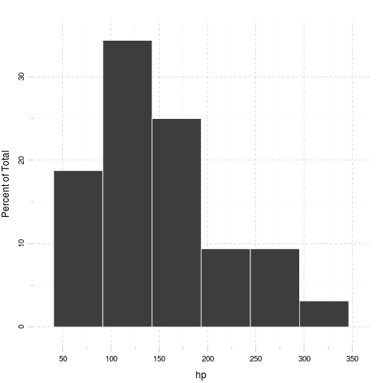

drat
We found the folloing values here:
3.9, 3.9, 3.85, 3.08, 3.15, 2.76, 3.21, 3.69, 3.92, 3.92, 3.92, 3.07, 3.07, 3.07, 2.93, 3, 3.23, 4.08, 4.93, 4.22, 3.7, 2.76, 3.15, 3.73, 3.08, 4.08, 4.43, 3.77, 4.22, 3.62, 3.54 and 4.11
The mean of drat is 3.597 while the standard deviation is: 0.5347. The most frequent value in drat is 3.07, but let us check out the frequency table too:
Table continues below
2.76 | 2.93 | 3 | 3.07 | 3.08 | 3.15 | 3.21 | 3.23 | 3.54 | 3.62 | 3.69 | 3.7
2 | 1 | 1 | 3 | 2 | 2 | 1 | 1 | 1 | 1 | 1 | 1
3.73 | 3.77 | 3.85 | 3.9 | 3.92 | 4.08 | 4.11 | 4.22 | 4.43 | 4.93
1 | 1 | 1 | 2 | 3 | 2 | 1 | 2 | 1 | 1
Tables are boring, let us show the same with a histogram:
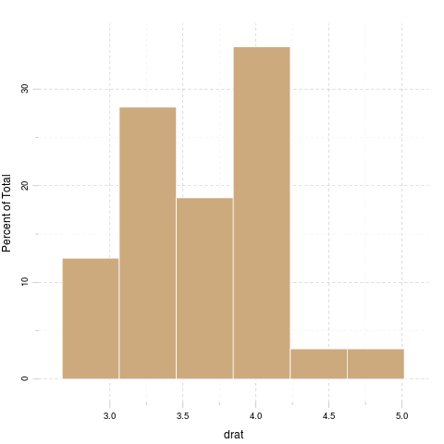

wt
We found the folloing values here:
2.62, 2.875, 2.32, 3.215, 3.44, 3.46, 3.57, 3.19, 3.15, 3.44, 3.44, 4.07, 3.73, 3.78, 5.25, 5.424, 5.345, 2.2, 1.615, 1.835, 2.465, 3.52, 3.435, 3.84, 3.845, 1.935, 2.14, 1.513, 3.17, 2.77, 3.57 and 2.78
The mean of wt is 3.217 while the standard deviation is: 0.9785. The most frequent value in wt is 3.44, but let us check out the frequency table too:
Table continues below
1.513 | 1.615 | 1.835 | 1.935 | 2.14 | 2.2 | 2.32 | 2.465 | 2.62 | 2.77 | 2.78
1 | 1 | 1 | 1 | 1 | 1 | 1 | 1 | 1 | 1 | 1
Table continues below
2.875 | 3.15 | 3.17 | 3.19 | 3.215 | 3.435 | 3.44 | 3.46 | 3.52 | 3.57 | 3.73
1 | 1 | 1 | 1 | 1 | 1 | 3 | 1 | 1 | 2 | 1
3.78 | 3.84 | 3.845 | 4.07 | 5.25 | 5.345 | 5.424
1 | 1 | 1 | 1 | 1 | 1 | 1
Tables are boring, let us show the same with a histogram:
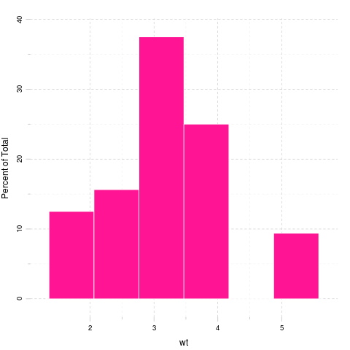

qsec
We found the folloing values here:
16.46, 17.02, 18.61, 19.44, 17.02, 20.22, 15.84, 20, 22.9, 18.3, 18.9, 17.4, 17.6, 18, 17.98, 17.82, 17.42, 19.47, 18.52, 19.9, 20.01, 16.87, 17.3, 15.41, 17.05, 18.9, 16.7, 16.9, 14.5, 15.5, 14.6 and 18.6
The mean of qsec is 17.85 while the standard deviation is: 1.787. The most frequent value in qsec is 17.02, but let us check out the frequency table too:
Table continues below
14.5 | 14.6 | 15.41 | 15.5 | 15.84 | 16.46 | 16.7 | 16.87 | 16.9 | 17.02
1 | 1 | 1 | 1 | 1 | 1 | 1 | 1 | 1 | 2
Table continues below
17.05 | 17.3 | 17.4 | 17.42 | 17.6 | 17.82 | 17.98 | 18 | 18.3 | 18.52 | 18.6
1 | 1 | 1 | 1 | 1 | 1 | 1 | 1 | 1 | 1 | 1
18.61 | 18.9 | 19.44 | 19.47 | 19.9 | 20 | 20.01 | 20.22 | 22.9
1 | 2 | 1 | 1 | 1 | 1 | 1 | 1 | 1
Tables are boring, let us show the same with a histogram:
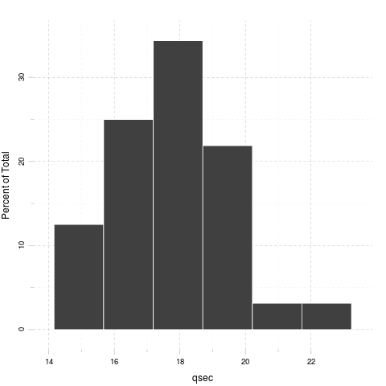

vs
We found the folloing values here:
0, 0, 1, 1, 0, 1, 0, 1, 1, 1, 1, 0, 0, 0, 0, 0, 0, 1, 1, 1, 1, 0, 0, 0, 0, 1, 0, 1, 0, 0, 0 and 1
The mean of vs is 0.4375 while the standard deviation is: 0.504. The most frequent value in vs is 0, but let us check out the frequency table too:
0 | 1
18 | 14
Tables are boring, let us show the same with a histogram:
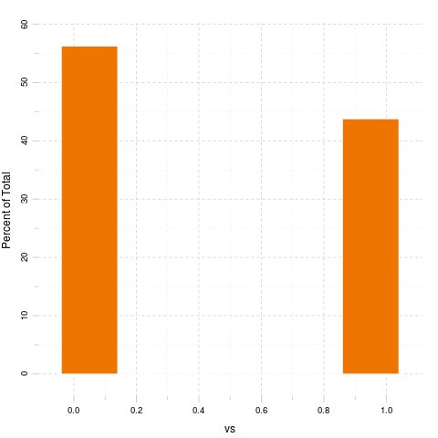

am
We found the folloing values here:
1, 1, 1, 0, 0, 0, 0, 0, 0, 0, 0, 0, 0, 0, 0, 0, 0, 1, 1, 1, 0, 0, 0, 0, 0, 1, 1, 1, 1, 1, 1 and 1
The mean of am is 0.4062 while the standard deviation is: 0.499. The most frequent value in am is 0, but let us check out the frequency table too:
0 | 1
19 | 13
Tables are boring, let us show the same with a histogram:
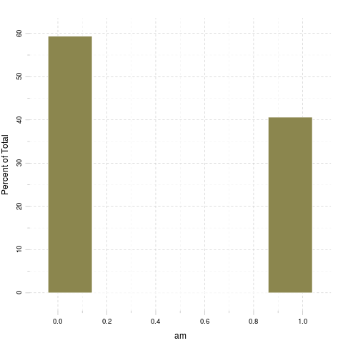

gear
We found the folloing values here:
4, 4, 4, 3, 3, 3, 3, 4, 4, 4, 4, 3, 3, 3, 3, 3, 3, 4, 4, 4, 3, 3, 3, 3, 3, 4, 5, 5, 5, 5, 5 and 4
The mean of gear is 3.688 while the standard deviation is: 0.7378. The most frequent value in gear is 3, but let us check out the frequency table too:
3 | 4 | 5
15 | 12 | 5
Tables are boring, let us show the same with a histogram:
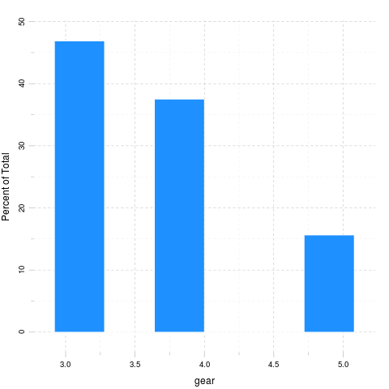

carb
We found the folloing values here:
4, 4, 1, 1, 2, 1, 4, 2, 2, 4, 4, 3, 3, 3, 4, 4, 4, 1, 2, 1, 1, 2, 2, 4, 2, 1, 2, 2, 4, 6, 8 and 2
The mean of carb is 2.812 while the standard deviation is: 1.615. The most frequent value in carb is 2, but let us check out the frequency table too:
1 | 2 | 3 | 4 | 6 | 8
7 | 10 | 3 | 10 | 1 | 1
Tables are boring, let us show the same with a histogram:
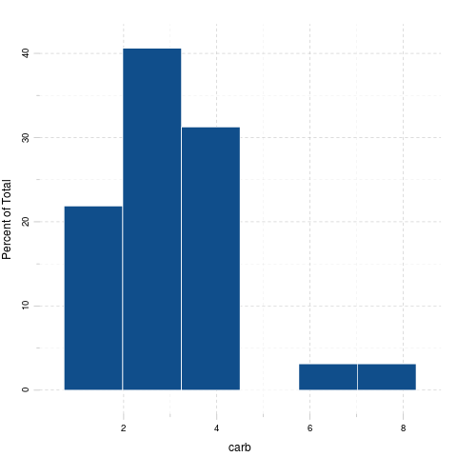

Correlation
And here goes a correlation table:
Table continues below
 | mpg | cyl | disp | hp | drat | wt | qsec | vs
mpg | 1 | -0.8522 | -0.8476 | -0.7762 | 0.6812 | -0.8677 | 0.4187 | 0.664
cyl | -0.8522 | 1 | 0.902 | 0.8324 | -0.6999 | 0.7825 | -0.5912 | -0.8108
disp | -0.8476 | 0.902 | 1 | 0.7909 | -0.7102 | 0.888 | -0.4337 | -0.7104
hp | -0.7762 | 0.8324 | 0.7909 | 1 | -0.4488 | 0.6587 | -0.7082 | -0.7231
drat | 0.6812 | -0.6999 | -0.7102 | -0.4488 | 1 | -0.7124 | 0.0912 | 0.4403
wt | -0.8677 | 0.7825 | 0.888 | 0.6587 | -0.7124 | 1 | -0.1747 | -0.5549
qsec | 0.4187 | -0.5912 | -0.4337 | -0.7082 | 0.0912 | -0.1747 | 1 | 0.7445
vs | 0.664 | -0.8108 | -0.7104 | -0.7231 | 0.4403 | -0.5549 | 0.7445 | 1
am | 0.5998 | -0.5226 | -0.5912 | -0.2432 | 0.7127 | -0.6925 | -0.2299 | 0.1683
gear | 0.4803 | -0.4927 | -0.5556 | -0.1257 | 0.6996 | -0.5833 | -0.2127 | 0.206
carb | -0.5509 | 0.527 | 0.395 | 0.7498 | -0.09079 | 0.4276 | -0.6562 | -0.5696
 | am | gear | carb
mpg | 0.5998 | 0.4803 | -0.5509
cyl | -0.5226 | -0.4927 | 0.527
disp | -0.5912 | -0.5556 | 0.395
hp | -0.2432 | -0.1257 | 0.7498
drat | 0.7127 | 0.6996 | -0.09079
wt | -0.6925 | -0.5833 | 0.4276
qsec | -0.2299 | -0.2127 | -0.6562
vs | 0.1683 | 0.206 | -0.5696
am | 1 | 0.7941 | 0.05753
gear | 0.7941 | 1 | 0.2741
carb | 0.05753 | 0.2741 | 1
And the same on a graph:
Yeah, that latter took a while to render in an image file :)
That's not a pander issue.

Some models
Okay, let us find out how weight affects other variables:

mpg
A simple linear model: mtcars$wt ~ mtcars$mpg
Fitting linear model: mtcars$wt ~ Independent
 | Estimate | Std. Error | t value | Pr(>|t|)
(Intercept) | 6.047 | 0.3087 | 19.59 | 1.204e-18
Independent | -0.1409 | 0.01474 | -9.559 | 1.294e-10

cyl
A simple linear model: mtcars$wt ~ mtcars$cyl
Fitting linear model: mtcars$wt ~ Independent
 | Estimate | Std. Error | t value | Pr(>|t|)
(Intercept) | 0.5646 | 0.4006 | 1.409 | 0.169
Independent | 0.4287 | 0.06228 | 6.883 | 1.218e-07

disp
A simple linear model: mtcars$wt ~ mtcars$disp
Fitting linear model: mtcars$wt ~ Independent
 | Estimate | Std. Error | t value | Pr(>|t|)
(Intercept) | 1.6 | 0.173 | 9.248 | 2.738e-10
Independent | 0.00701 | 0.0006629 | 10.58 | 1.222e-11

hp
A simple linear model: mtcars$wt ~ mtcars$hp
Fitting linear model: mtcars$wt ~ Independent
 | Estimate | Std. Error | t value | Pr(>|t|)
(Intercept) | 1.838 | 0.3165 | 5.808 | 2.389e-06
Independent | 0.009401 | 0.00196 | 4.796 | 4.146e-05

drat
A simple linear model: mtcars$wt ~ mtcars$drat
Fitting linear model: mtcars$wt ~ Independent
 | Estimate | Std. Error | t value | Pr(>|t|)
(Intercept) | 7.906 | 0.8522 | 9.277 | 2.547e-10
Independent | -1.304 | 0.2345 | -5.561 | 4.784e-06

qsec
A simple linear model: mtcars$wt ~ mtcars$qsec
Fitting linear model: mtcars$wt ~ Independent
 | Estimate | Std. Error | t value | Pr(>|t|)
(Intercept) | 4.925 | 1.765 | 2.79 | 0.009081
Independent | -0.09567 | 0.09843 | -0.9719 | 0.3389

vs
A simple linear model: mtcars$wt ~ mtcars$vs
Fitting linear model: mtcars$wt ~ Independent
 | Estimate | Std. Error | t value | Pr(>|t|)
(Intercept) | 3.689 | 0.195 | 18.91 | 3.203e-18
Independent | -1.077 | 0.2949 | -3.654 | 0.0009798

am
A simple linear model: mtcars$wt ~ mtcars$am
Fitting linear model: mtcars$wt ~ Independent
 | Estimate | Std. Error | t value | Pr(>|t|)
(Intercept) | 3.769 | 0.1646 | 22.89 | 1.49e-20
Independent | -1.358 | 0.2583 | -5.258 | 1.125e-05

gear
A simple linear model: mtcars$wt ~ mtcars$gear
Fitting linear model: mtcars$wt ~ Independent
 | Estimate | Std. Error | t value | Pr(>|t|)
(Intercept) | 6.07 | 0.7392 | 8.212 | 3.632e-09
Independent | -0.7735 | 0.1967 | -3.933 | 0.0004587

carb
A simple linear model: mtcars$wt ~ mtcars$carb
Fitting linear model: mtcars$wt ~ Independent
 | Estimate | Std. Error | t value | Pr(>|t|)
(Intercept) | 2.489 | 0.323 | 7.705 | 1.353e-08
Independent | 0.259 | 0.09998 | 2.591 | 0.01464

