Rapport package team
ANOVA Template
2011-04-26 20:25 CET

Description
An ANOVA report with table of descriptives, diagnostic tests and ANOVA-specific statistics.

Introduction
Analysis of Variance or ANOVA is a statistical procedure that tests equality of means for several samples. It was first introduced in 1921 by famous English statistician Sir Ronald Aylmer Fisher.

Model Overview
One-Way ANOVA was carried out, with Gender as independent variable, and Internet usage in leisure time (hours per day) as a response variable. Factor interaction was taken into account.

Descriptives
In order to get more insight on the model data, a table of frequencies for ANOVA factors is displayed, as well as a table of descriptives.

Frequency Table
Below lies a frequency table for factors in ANOVA model. Note that the missing values are removed from the summary.
gender | N | % | Cumul. N | Cumul. %
male | 410 | 60.92 | 410 | 60.92
female | 263 | 39.08 | 673 | 100
Total | 673 | 100 | 673 | 100

Descriptive Statistics
The following table displays the descriptive statistics of ANOVA model. Factor levels lie on the left-hand side, while the corresponding statistics for response variable are given on the right-hand side.
Gender | Min | Max | Mean | Std.Dev. | Median | IQR
male | 0 | 12 | 3.27 | 1.953 | 3 | 3
female | 0 | 12 | 3.064 | 2.355 | 2 | 3
Table continues below
Skewness | Kurtosis
0.9443 | 0.9858
1.398 | 1.87

Diagnostics
Before we carry out ANOVA, we'd like to check some basic assumptions. For those purposes, normality and homoscedascity tests are carried out alongside several graphs that may help you with your decision on model's main assumptions.

Diagnostics

Univariate Normality
Method | Statistic | p-value
Lilliefors (Kolmogorov-Smirnov) normality test | 0.168 | 3e-52
Anderson-Darling normality test | 18.75 | 7.261e-44
Shapiro-Wilk normality test | 0.9001 | 1.618e-20
So, the conclusions we can draw with the help of test statistics:
- based on Lilliefors test, distribution of Internet usage in leisure time (hours per day) is not normal
- Anderson-Darling test confirms violation of normality assumption
- according to Shapiro-Wilk test, the distribution of Internet usage in leisure time (hours per day) is not normal
As you can see, the applied tests confirm departures from normality of the Internet usage in leisure time (hours per day).

Homoscedascity
In order to test homoscedascity, Bartlett and Fligner-Kileen tests are applied.
Method | Statistic | p-value
Fligner-Killeen test of homogeneity of variances | 0.4629 | 0.4963
Bartlett test of homogeneity of variances | 10.77 | 0.001032
When it comes to equality of variances, applied tests yield inconsistent results. While Fligner-Kileen test confirmed the hypotheses of homoscedascity, Bartlett's test rejected it.

Diagnostic Plots
Here you can see several diagnostic plots for ANOVA model:
- residuals against fitted values
- scale-location plot of square root of residuals against fitted values
- normal Q-Q plot
- residuals against leverages
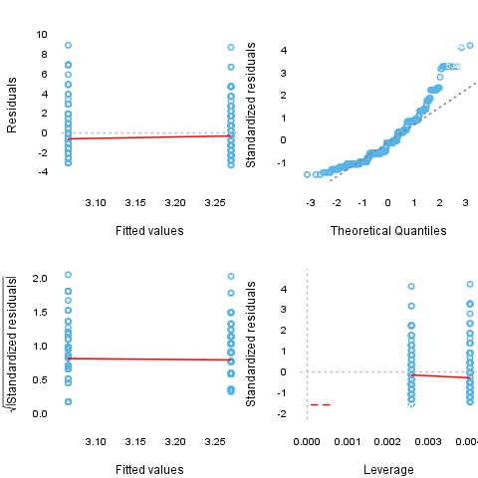

ANOVA Summary

ANOVA Table
 | Df | Sum.Sq | Mean.Sq | F.value | Pr..F.
gender | 1 | 6.422 | 6.422 | 1.43 | 0.2322
Residuals | 636 | 2856 | 4.49
F-test for Gender is not statistically significant, which implies that there is no Gender effect on response variable.

Post Hoc test

Results
After getting the results of the ANOVA, usually it is advisable to run a post hoc test to explore patterns that were not specified a priori. Now we are presenting Tukey's HSD test.
gender
 | Difference | Lower Bound | Upper Bound
female-male | -0.206 | -0.543 | 0.132
Table continues below
 | P value
female-male | 0.232
There are no categories which differ significantly here.

Plot
Below you can see the result of the post hoc test on a plot.
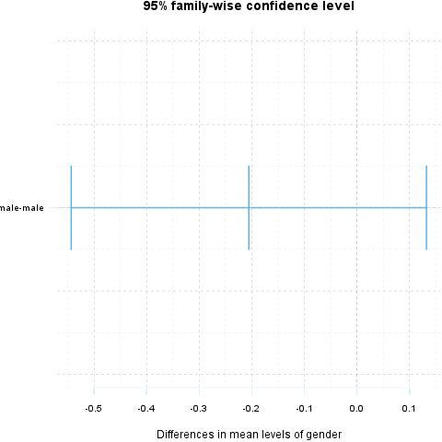

Description
An ANOVA report with table of descriptives, diagnostic tests and ANOVA-specific statistics.

Introduction
Analysis of Variance or ANOVA is a statistical procedure that tests equality of means for several samples. It was first introduced in 1921 by famous English statistician Sir Ronald Aylmer Fisher.

Model Overview
Two-Way ANOVA was carried out, with Gender and Relationship status as independent variables, and Internet usage in leisure time (hours per day) as a response variable. Factor interaction was taken into account.

Descriptives
In order to get more insight on the model data, a table of frequencies for ANOVA factors is displayed, as well as a table of descriptives.

Frequency Table
Below lies a frequency table for factors in ANOVA model. Note that the missing values are removed from the summary.
gender | partner | N | % | Cumul. N | Cumul. %
male | in a relationship | 150 | 23.7 | 150 | 23.7
female | in a relationship | 120 | 18.96 | 270 | 42.65
male | married | 33 | 5.213 | 303 | 47.87
female | married | 29 | 4.581 | 332 | 52.45
male | single | 204 | 32.23 | 536 | 84.68
female | single | 97 | 15.32 | 633 | 100
Total | Total | 633 | 100 | 633 | 100

Descriptive Statistics
The following table displays the descriptive statistics of ANOVA model. Factor levels and their combinations lie on the left-hand side, while the corresponding statistics for response variable are given on the right-hand side.
Gender | Relationship status | Min | Max | Mean | Std.Dev.
male | in a relationship | 0.5 | 12 | 3.058 | 1.969
male | married | 0 | 8 | 2.985 | 2.029
male | single | 0 | 10 | 3.503 | 1.936
female | in a relationship | 0.5 | 10 | 3.044 | 2.216
female | married | 0 | 10 | 2.481 | 1.967
female | single | 0 | 12 | 3.323 | 2.679
Table continues below
Median | IQR | Skewness | Kurtosis
2.5 | 2 | 1.324 | 2.649
3 | 2 | 0.862 | 0.1509
3 | 3 | 0.7574 | 0.08749
3 | 3 | 1.383 | 1.831
2 | 1.75 | 2.063 | 5.586
3 | 3.5 | 1.185 | 0.9281

Diagnostics
Before we carry out ANOVA, we'd like to check some basic assumptions. For those purposes, normality and homoscedascity tests are carried out alongside several graphs that may help you with your decision on model's main assumptions.

Diagnostics

Univariate Normality
Method | Statistic | p-value
Lilliefors (Kolmogorov-Smirnov) normality test | 0.168 | 3e-52
Anderson-Darling normality test | 18.75 | 7.261e-44
Shapiro-Wilk normality test | 0.9001 | 1.618e-20
So, the conclusions we can draw with the help of test statistics:
- based on Lilliefors test, distribution of Internet usage in leisure time (hours per day) is not normal
- Anderson-Darling test confirms violation of normality assumption
- according to Shapiro-Wilk test, the distribution of Internet usage in leisure time (hours per day) is not normal
As you can see, the applied tests confirm departures from normality of the Internet usage in leisure time (hours per day).

Homoscedascity
In order to test homoscedascity, Bartlett and Fligner-Kileen tests are applied.
Method | Statistic | p-value
Fligner-Killeen test of homogeneity of variances | 1.123 | 0.2892
Bartlett test of homogeneity of variances | 11.13 | 0.0008509
When it comes to equality of variances, applied tests yield inconsistent results. While Fligner-Kileen test confirmed the hypotheses of homoscedascity, Bartlett's test rejected it.

Diagnostic Plots
Here you can see several diagnostic plots for ANOVA model:
- residuals against fitted values
- scale-location plot of square root of residuals against fitted values
- normal Q-Q plot
- residuals against leverages
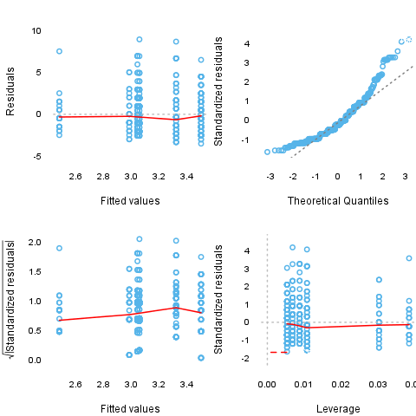

ANOVA Summary

ANOVA Table
 | Df | Sum.Sq | Mean.Sq | F.value
gender | 1 | 4.947 | 4.947 | 1.085
partner | 2 | 31.21 | 15.61 | 3.424
gender:partner | 2 | 3.038 | 1.519 | 0.3332
Residuals | 593 | 2703 | 4.558
Table continues below
 | Pr..F.
gender | 0.2979
partner | 0.03324
gender:partner | 0.7168
Residuals
F-test for Gender is not statistically significant, which implies that there is no Gender effect on response variable. Effect of Relationship status on response variable is significant. Interaction between levels of Gender and Relationship status wasn't found significant (p = 0.717).

Post Hoc test

Results
After getting the results of the ANOVA, usually it is advisable to run a post hoc test to explore patterns that were not specified a priori. Now we are presenting Tukey's HSD test.
gender
 | Difference | Lower Bound | Upper Bound
female-male | -0.186 | -0.538 | 0.165
Table continues below
 | P value
female-male | 0.298
There are no categories which differ significantly here.
partner
 | Difference | Lower Bound
married-in a relationship | -0.289 | -1.012
single-in a relationship | 0.371 | -0.061
single-married | 0.66 | -0.059
Table continues below
 | Upper Bound | P value
married-in a relationship | 0.435 | 0.616
single-in a relationship | 0.803 | 0.109
single-married | 1.379 | 0.079
There are no categories which differ significantly here.
gender:partner
 | Difference | Lower Bound
female:in a relationship-male:in a relationship | -0.014 | -0.777
male:married-male:in a relationship | -0.073 | -1.25
female:married-male:in a relationship | -0.577 | -1.877
male:single-male:in a relationship | 0.444 | -0.23
female:single-male:in a relationship | 0.264 | -0.545
male:married-female:in a relationship | -0.059 | -1.266
female:married-female:in a relationship | -0.563 | -1.89
male:single-female:in a relationship | 0.459 | -0.267
female:single-female:in a relationship | 0.279 | -0.574
female:married-male:married | -0.504 | -2.105
male:single-male:married | 0.518 | -0.635
female:single-male:married | 0.338 | -0.899
male:single-female:married | 1.022 | -0.256
female:single-female:married | 0.842 | -0.512
female:single-male:single | -0.18 | -0.955
Table continues below
 | Upper Bound | P value
female:in a relationship-male:in a relationship | 0.749 | 1
male:married-male:in a relationship | 1.103 | 1
female:married-male:in a relationship | 0.722 | 0.801
male:single-male:in a relationship | 1.119 | 0.412
female:single-male:in a relationship | 1.074 | 0.938
male:married-female:in a relationship | 1.148 | 1
female:married-female:in a relationship | 0.764 | 0.83
male:single-female:in a relationship | 1.184 | 0.461
female:single-female:in a relationship | 1.132 | 0.938
female:married-male:married | 1.097 | 0.946
male:single-male:married | 1.67 | 0.794
female:single-male:married | 1.575 | 0.971
male:single-female:married | 2.3 | 0.201
female:single-female:married | 2.196 | 0.481
female:single-male:single | 0.594 | 0.986
There are no categories which differ significantly here.

Plot
Below you can see the result of the post hoc test on a plot.
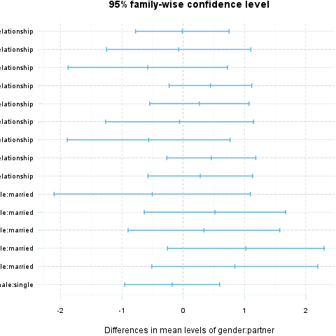

This report was generated with R (3.0.1) and rapport (0.51) in 3.431 sec on x86_64-unknown-linux-gnu platform.

