Rapport package team
Kolmogorov-Smirnov-test
2011-04-26 20:25 CET

Description
This template will run a Kolmogorov-Smirnov-test

Introduction
Kolmogorov-Smirnov test is one of the most widely used nonparametric tests. With the help of that in this case we use to check if two continuous variables had the same distribution. We do not test that here, but there is a possibility to use that in the way to check if a sample/variable followed an expected distribution.

Distributions
Before we use the K-S test to look at the possible statistical differences, it could be useful to see visually the distributions we want to observe. Below lie the Cumulative Distribution Functions of the variables we compared:
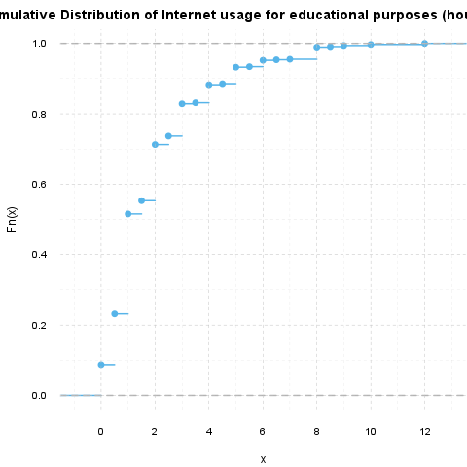
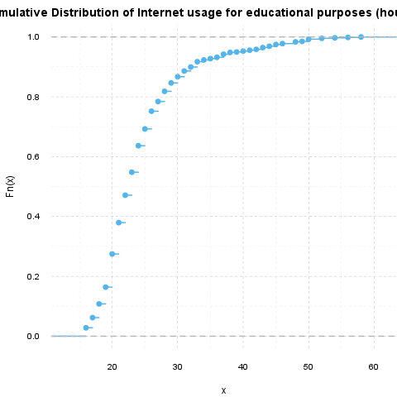

Test results
Now we will test if the Internet usage for educational purposes (hours per day) and the Age had statistically the same distribution.
Test statistic | P value | Alternative hypothesis
1 | 0 * * * | two-sided
Two-sample Kolmogorov-Smirnov test on Internet usage for educational purposes (hours per day) and Age
The requirements of the Kolmogorov-Smirnov Test test was not met, the approximation may be incorrect.
So the variables do not follow the same distribution, according to the Kolmogorov-Smirnov test statistic.

Description
This template will run a Kolmogorov-Smirnov-test

Introduction
Kolmogorov-Smirnov test is one of the most widely used nonparametric tests. With the help of that in this case we use to check if two continuous variables had the same distribution. We do not test that here, but there is a possibility to use that in the way to check if a sample/variable followed an expected distribution.

Distributions
Before we use the K-S test to look at the possible statistical differences, it could be useful to see visually the distributions we want to observe. Below lie the Cumulative Distribution Functions of the variables we compared:
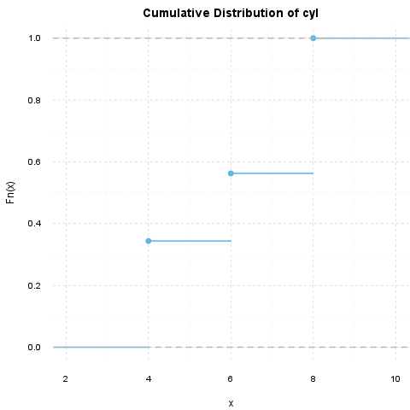
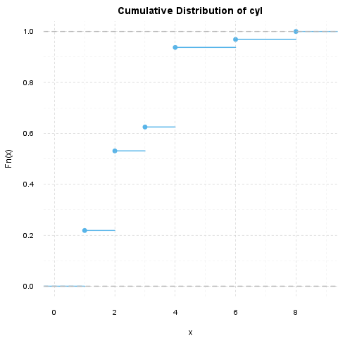

Test results
Now we will test if the cyl and the carb had statistically the same distribution.
Test statistic | P value | Alternative hypothesis
0.625 | 7.453e-06 * * * | two-sided
Two-sample Kolmogorov-Smirnov test on cyl and carb
The requirements of the Kolmogorov-Smirnov Test test was not met, the approximation may be incorrect.
So the variables do not follow the same distribution, according to the Kolmogorov-Smirnov test statistic.

This report was generated with R (3.0.1) and rapport (0.51) in 0.729 sec on x86_64-unknown-linux-gnu platform.

