Rapport package team
Multidimensional Scaling
2011-04-26 20:25 CET

Description
In this template Rapporter will present you Multidimensional Scaling.

Introduction
Multidimensional-scaling is a technique which gives us a visual representation about the distances between the observations.

MDS
Below you can see a plot, that presents you the distance between the observations, which was calculated based on Age, Internet usage for educational purposes (hours per day) and Internet usage in leisure time (hours per day).
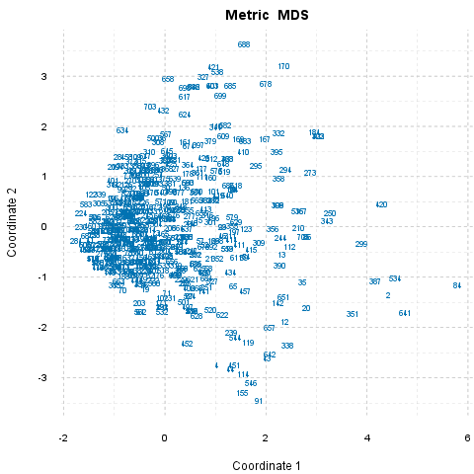

What can be seen here?
Outsiders
84 differs the most from the others, and 8 seems to be the most "common" observation, which lie nearest to all other observations.
Outsider Pairs
284 and 84 (8.02) are the "furthest", 280 and 1 (0) are the "nearest" to each other.
In General
Now let's see which observations can be said statistically far/similar to each other in general. The 16 pairs with the biggest differences and the 10 pairs with the smallest differences will be presented. In the brackets you can see the amount of the distances between two observations.
There are 17 observations which are the most similar, and equal in the same time, that is a higher number than the wanted 16, thus will not be reported one-by-one. Set 17 as parameter max.dist.num to check the pairs if you are interested.
There are 318 observations which are the most similar and equal in the same time, that is a higher number than the wanted 10, thus will not be reported one-by-one. Set 318 as parameter min.dist.num to check the pairs if you are interested.

Description
In this template Rapporter will present you Multidimensional Scaling.

Introduction
Multidimensional-scaling is a technique which gives us a visual representation about the distances between the observations.

MDS
Below you can see a plot, that presents you the distance between the observations, which was calculated based on Age, Internet usage for educational purposes (hours per day) and Internet usage in leisure time (hours per day).

What can be seen here?
Outsiders
84 differs the most from the others, and 8 seems to be the most "common" observation, which lie nearest to all other observations.
Outsider Pairs
284 and 84 (8.02) are the "furthest", 280 and 1 (0) are the "nearest" to each other.
In General
Now let's see which observations can be said statistically far/similar to each other in general. The 17 pairs with the biggest differences and the 30 pairs with the smallest differences will be presented. In the brackets you can see the amount of the distances between two observations.
According to the used variables (Age, Internet usage for educational purposes (hours per day) and Internet usage in leisure time (hours per day)) the 17 furthest pair of observations are:
- 284 and 84 (8.02)
- 224 and 84 (7.87)
- 230 and 84 (7.84)
- 84 and 68 (7.81)
- 463 and 84 (7.79)
- 583 and 84 (7.79)
- 582 and 84 (7.72)
- 122 and 84 (7.72)
- 460 and 84 (7.72)
- 606 and 84 (7.7)
- 607 and 84 (7.7)
- 128 and 84 (7.69)
- 253 and 84 (7.69)
- 84 and 41 (7.69)
- 269 and 84 (7.65)
- 376 and 84 (7.63)
- 506 and 84 (7.63)
There are 318 observations which are the most similar and equal in the same time, that is a higher number than the wanted 30, thus will not be reported one-by-one. Set 318 as parameter min.dist.num to check the pairs if you are interested.

Description
In this template Rapporter will present you Multidimensional Scaling.

Introduction
Multidimensional-scaling is a technique which gives us a visual representation about the distances between the observations.

MDS
Below you can see a plot, that presents you the distance between the observations, which was calculated based on drat, cyl and mpg.
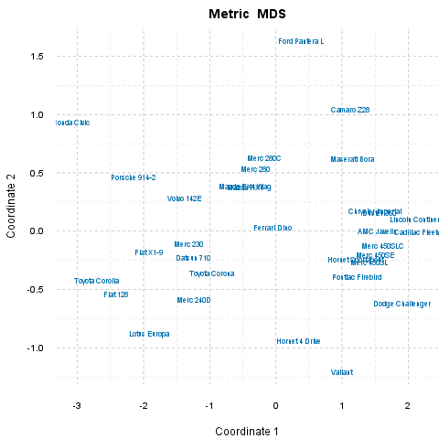

What can be seen here?
Outsiders
Honda Civic differs the most from the others, and Ferrari Dino seems to be the most "common" observation, which lie nearest to all other observations.
Outsider Pairs
Honda Civic and Cadillac Fleetwood (5.48) are the "furthest", Mazda RX4 Wag and Mazda RX4 (0) are the "nearest" to each other.
In General
Now let's see which observations can be said statistically far/similar to each other in general. The 17 pairs with the biggest differences and the 30 pairs with the smallest differences will be presented. In the brackets you can see the amount of the distances between two observations.
According to the used variables (drat, cyl and mpg) the 17 furthest pair of observations are:
- Honda Civic and Cadillac Fleetwood (5.48)
- Honda Civic and Lincoln Continental (5.39)
- Dodge Challenger and Honda Civic (5.25)
- Toyota Corolla and Cadillac Fleetwood (5.1)
- Toyota Corolla and Lincoln Continental (5.04)
- Honda Civic and Merc 450SLC (4.85)
- Fiat 128 and Cadillac Fleetwood (4.79)
- Honda Civic and Merc 450SE (4.74)
- Honda Civic and Duster 360 (4.74)
- AMC Javelin and Honda Civic (4.74)
- Fiat 128 and Lincoln Continental (4.74)
- Honda Civic and Chrysler Imperial (4.68)
- Honda Civic and Valiant (4.68)
- Honda Civic and Merc 450SL (4.67)
- Dodge Challenger and Toyota Corolla (4.67)
- Pontiac Firebird and Honda Civic (4.52)
- Honda Civic and Hornet Sportabout (4.46)
According to the used variables (drat, cyl and mpg) the 30 nearest pair of observations are:
- Mazda RX4 Wag and Mazda RX4 (0)
- Chrysler Imperial and Duster 360 (0.08)
- Merc 230 and Datsun 710 (0.13)
- Lincoln Continental and Cadillac Fleetwood (0.13)
- Merc 450SL and Merc 450SE (0.15)
- AMC Javelin and Merc 450SLC (0.15)
- Pontiac Firebird and Hornet Sportabout (0.15)
- AMC Javelin and Chrysler Imperial (0.17)
- AMC Javelin and Duster 360 (0.19)
- Merc 450SLC and Merc 450SE (0.2)
- Merc 280C and Merc 280 (0.23)
- AMC Javelin and Merc 450SE (0.25)
- Merc 450SL and Hornet Sportabout (0.28)
- Merc 280 and Mazda RX4 (0.3)
- Merc 280 and Mazda RX4 Wag (0.3)
- Merc 450SLC and Duster 360 (0.3)
- Chrysler Imperial and Merc 450SLC (0.31)
- Pontiac Firebird and Merc 450SL (0.32)
- Merc 450SLC and Merc 450SL (0.35)
- Toyota Corona and Datsun 710 (0.35)
- Toyota Corolla and Fiat 128 (0.36)
- AMC Javelin and Merc 450SL (0.38)
- Merc 240D and Datsun 710 (0.4)
- Merc 450SE and Hornet Sportabout (0.41)
- Chrysler Imperial and Merc 450SE (0.41)
- Volvo 142E and Merc 230 (0.42)
- Merc 450SE and Duster 360 (0.44)
- Maserati Bora and Camaro Z28 (0.45)
- Toyota Corona and Merc 230 (0.46)
- Pontiac Firebird and Merc 450SE (0.46)

This report was generated with R (3.0.1) and rapport (0.51) in 3.338 sec on x86_64-unknown-linux-gnu platform.

